**1. Set up an EC2 Instance**

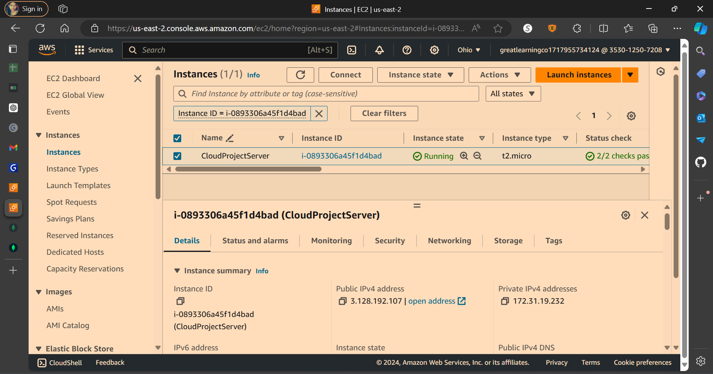

**Connect to your EC2 instance:**

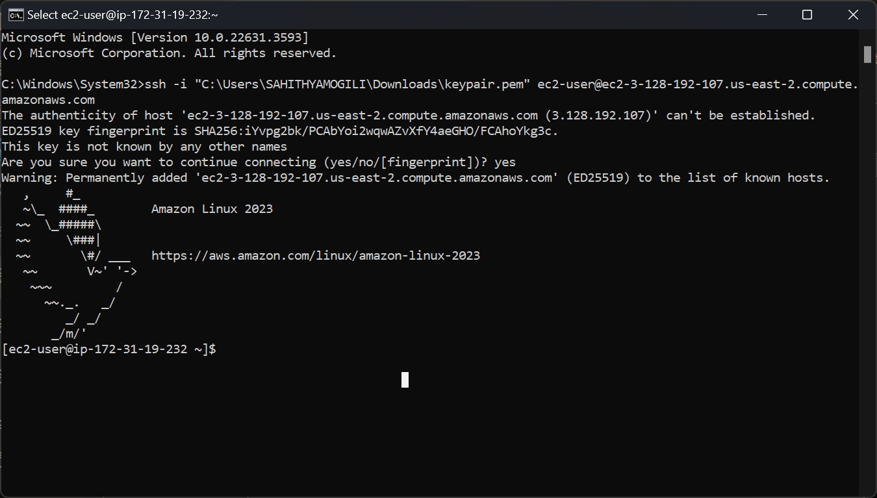

**2. Set Up MongoDB Atlas**

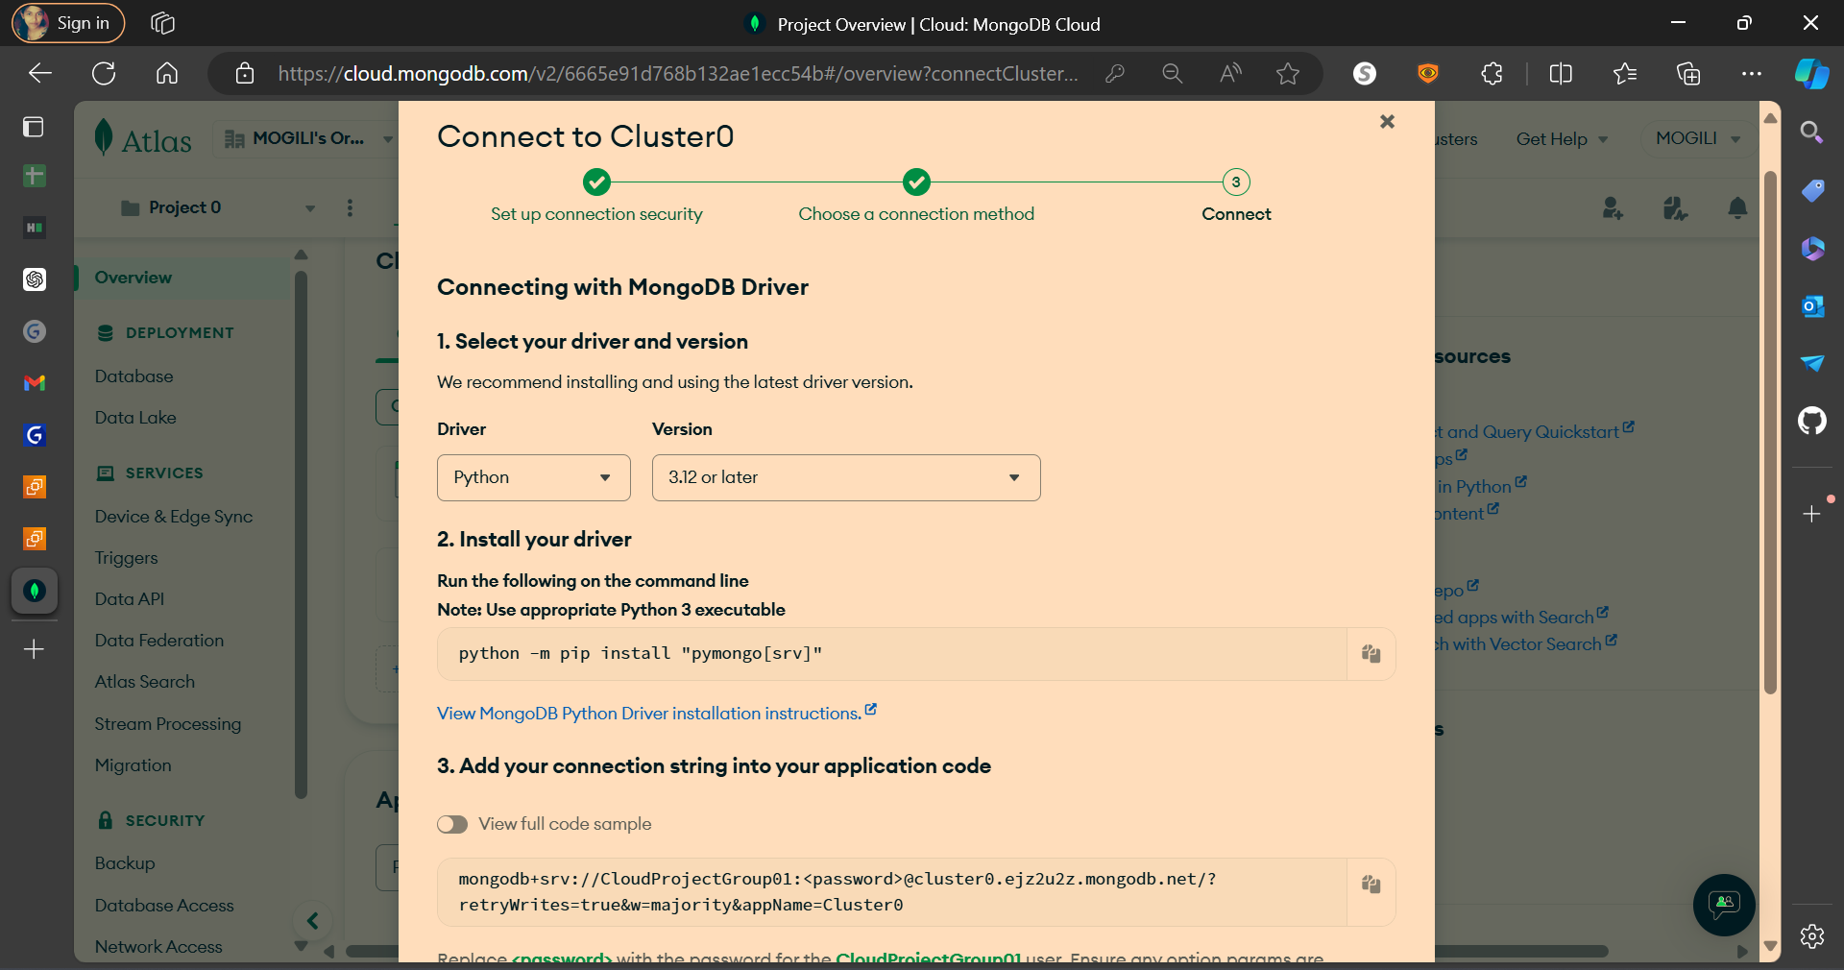

sudo yum update -y

sudo yum install python3 -y

sudo yum install python3-pip -y

sudo yum install git -y

git clone https://github.com/shivareddy0117/App_Cloud_Migration/

FROM python:3.9

# Set the working directory in the container

WORKDIR /app

# Copy the requirements file into the container

COPY requirements.txt requirements.txt

# Install any dependencies

RUN pip install --no-cache-dir -r requirements.txt

# Copy the current directory contents into the container at /app

COPY . .

# Make port 5000 available to the world outside this container

EXPOSE 5000

# Define environment variable

ENV FLASK_APP=app1.py

# Run the application

CMD ["gunicorn", "--bind", "0.0.0.0:5000", "app1:app"]

Ctrl + X to exit, Y to confirm

Docker-compose.yml file creation:

sudo curl -L "https://github.com/docker/compose/releases/download/1.29.2/docker-compose-$(uname -s)-$(uname -m)" -o /usr/local/bin/docker-compose

sudo docker-compose build

Testing /map endpoint

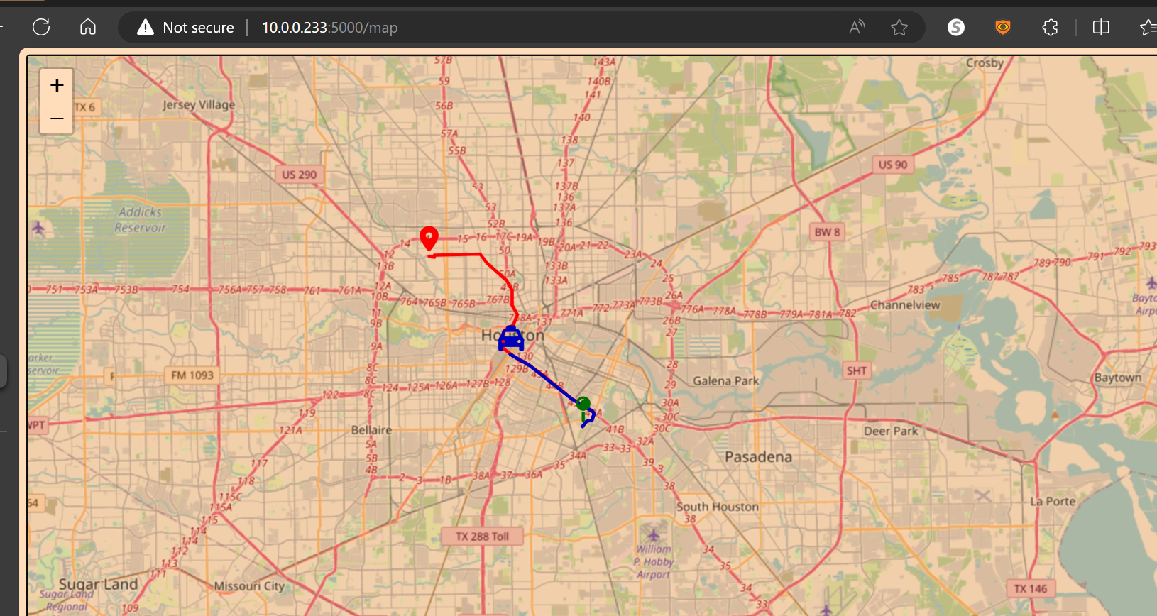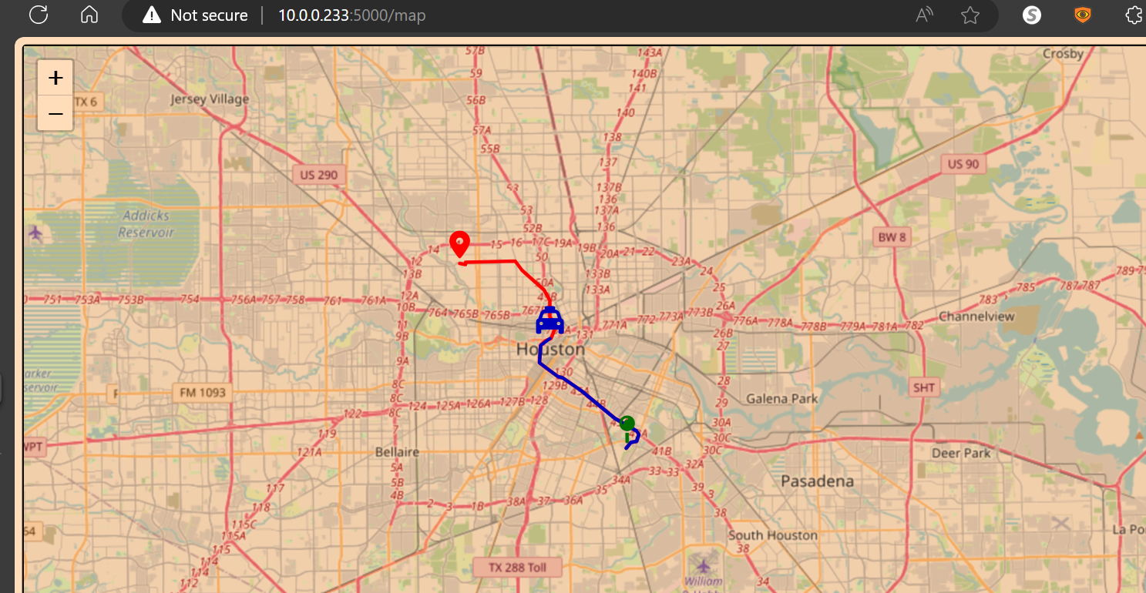

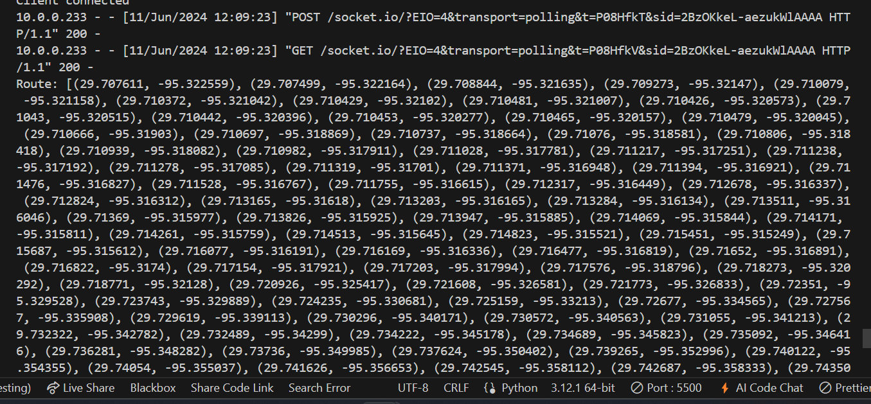

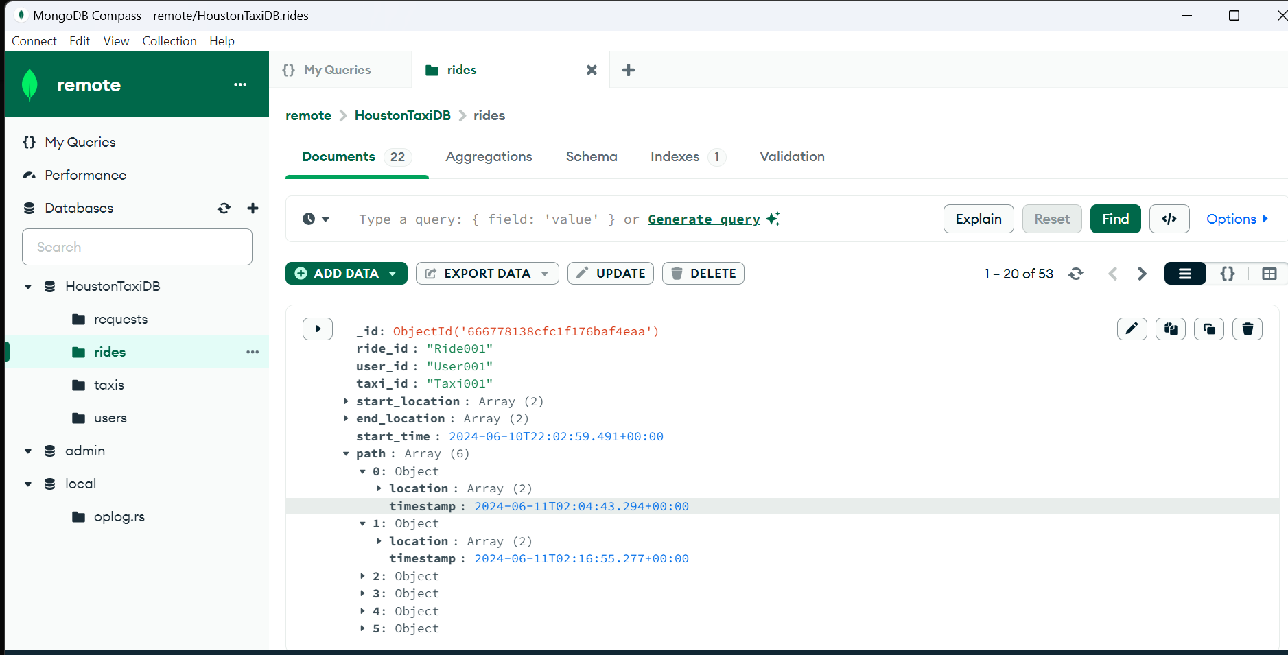

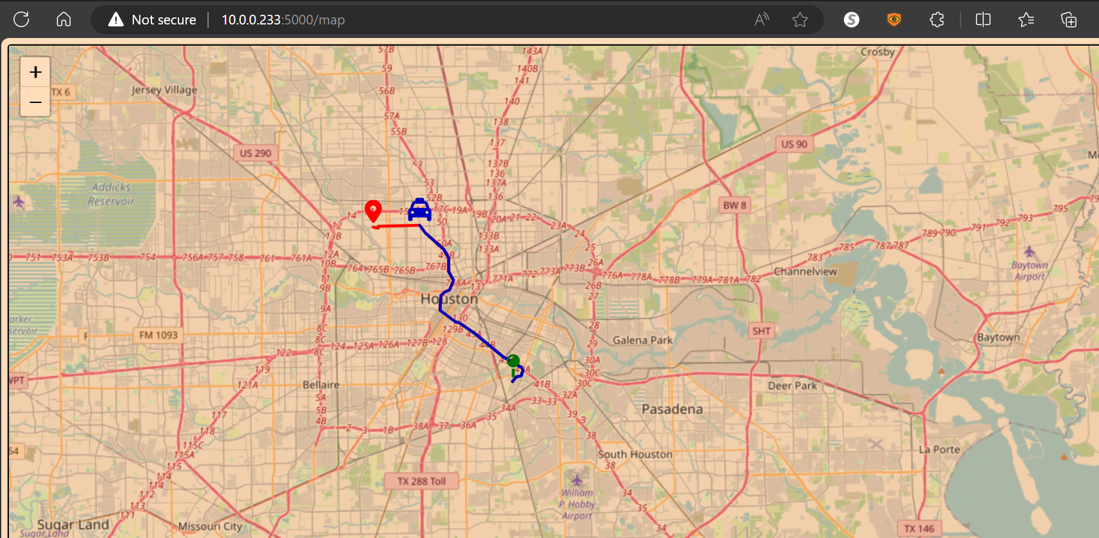

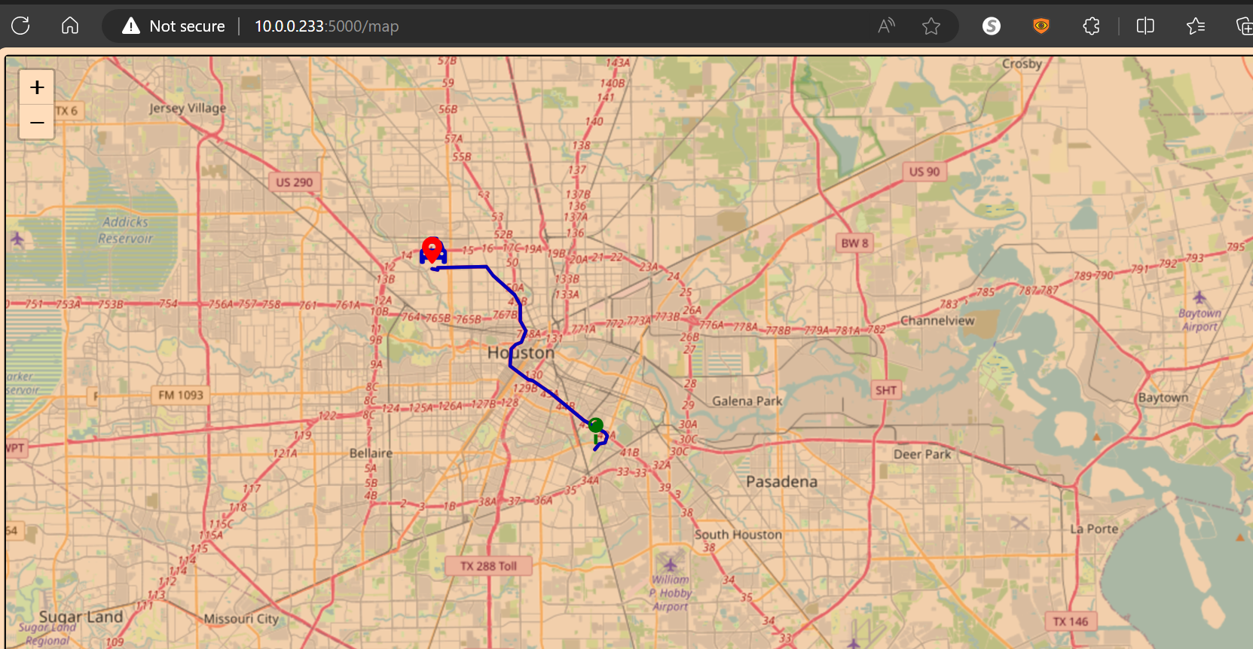

/ endpoint for the landing page

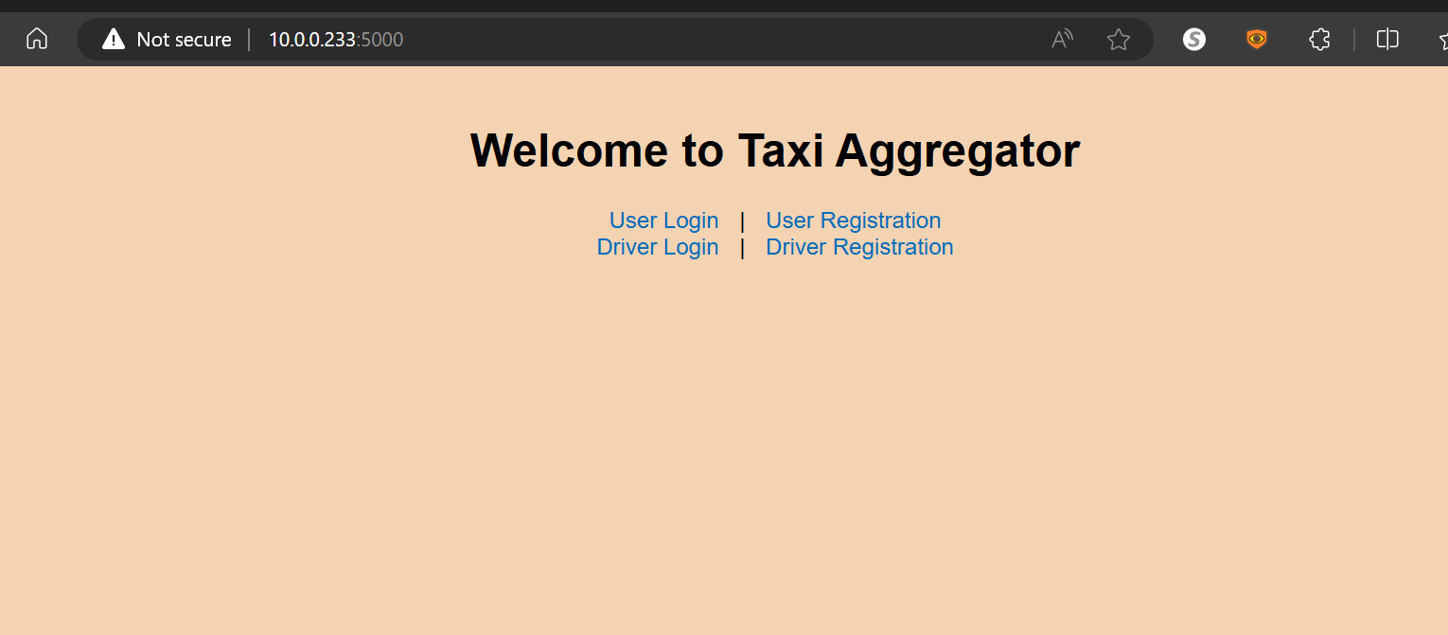

Initial visualizations of taxis

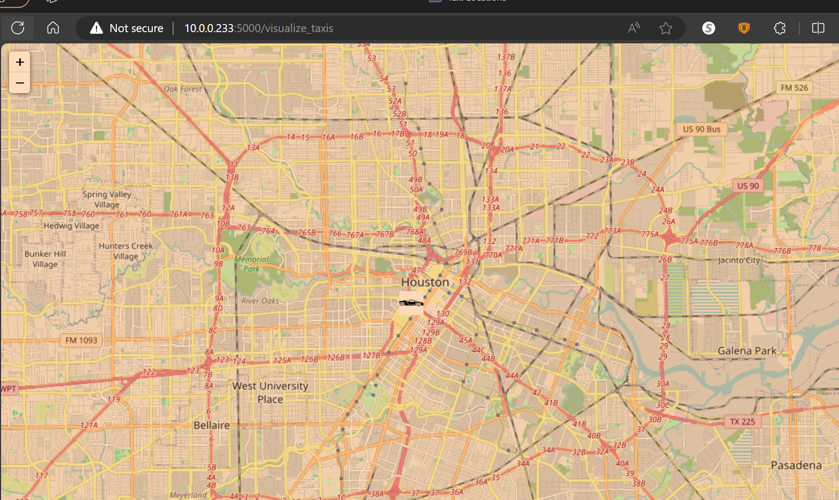

/register_user

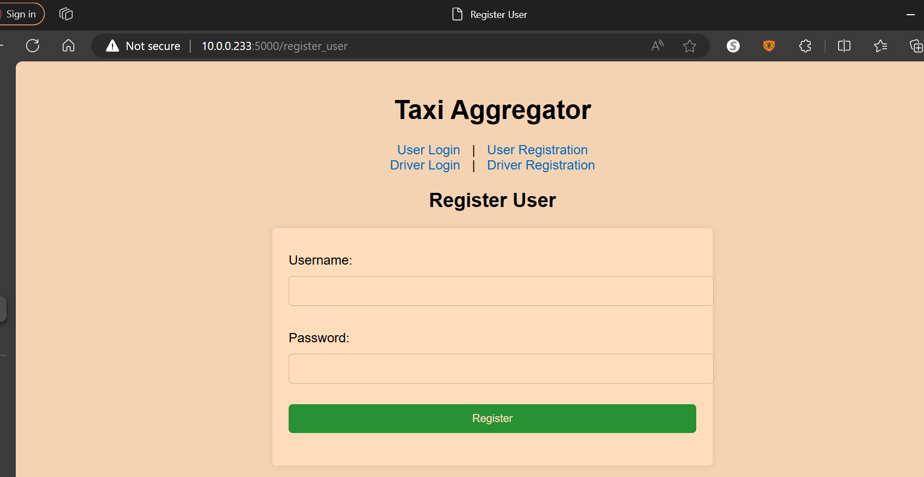

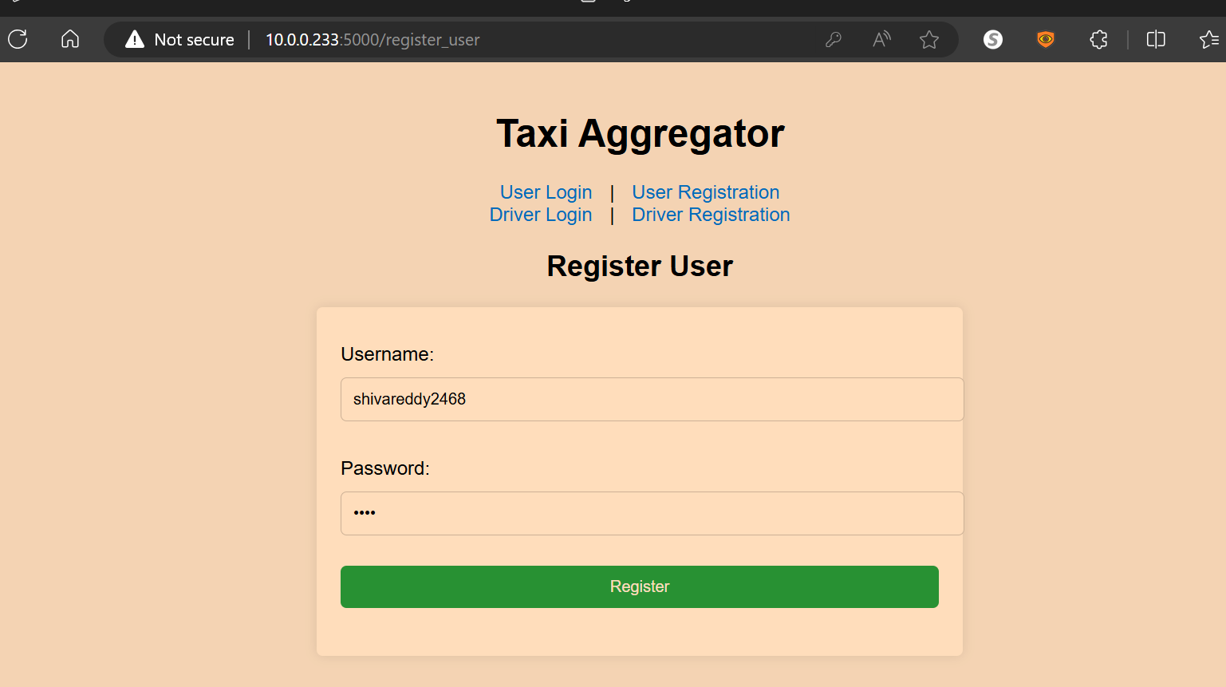

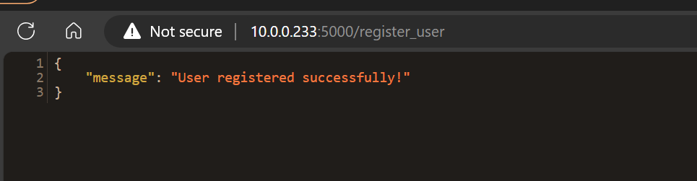

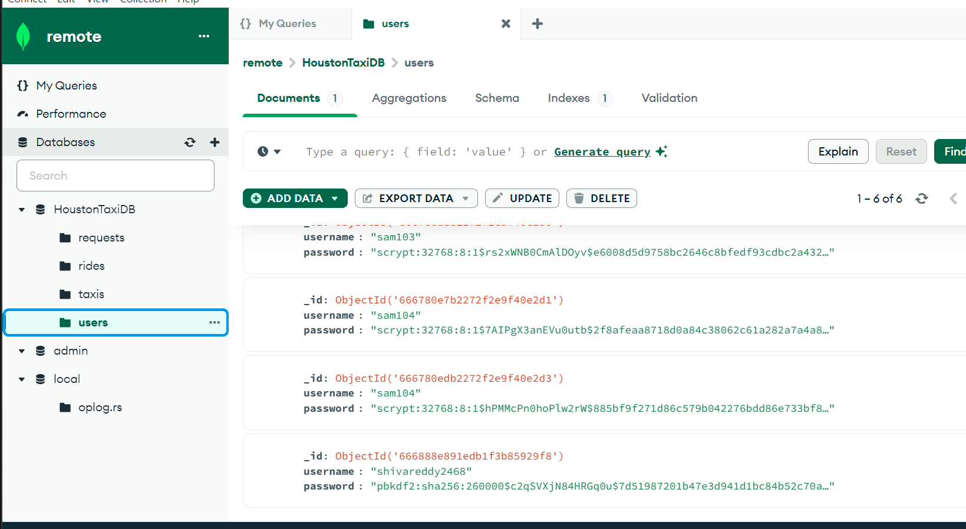

/ login_user

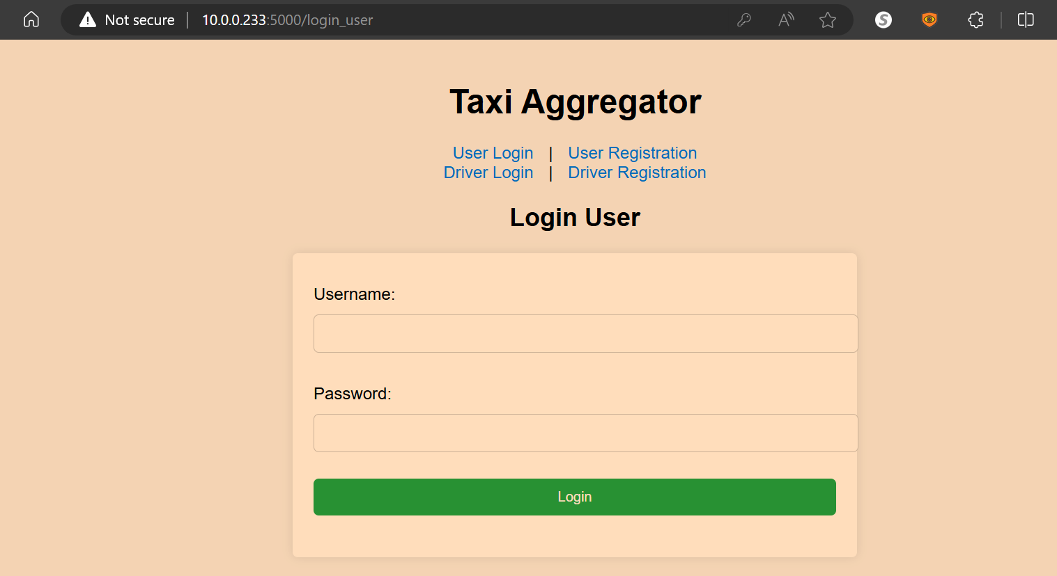

User_simulator

